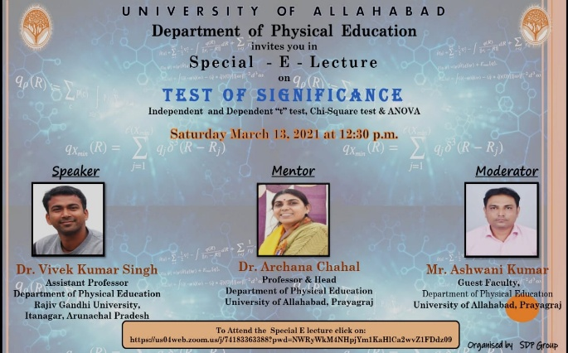
News Report
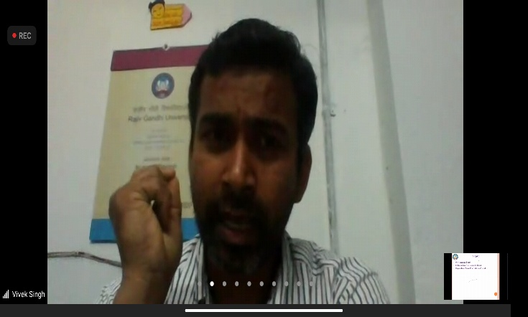
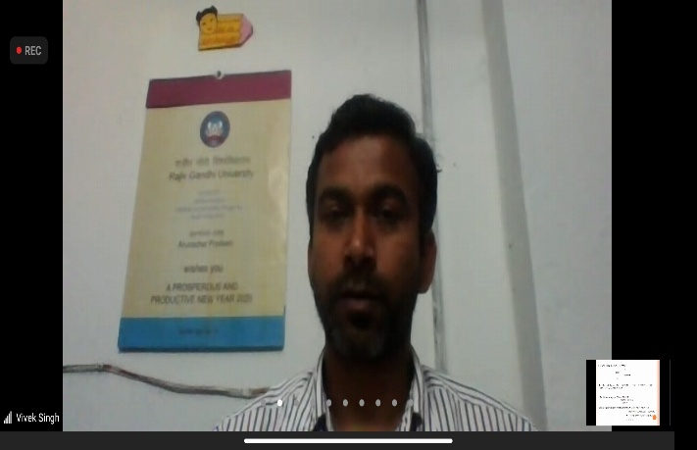
Today (13/03/2021) Department of Physical Education, University of Allahabad conducted a SPECIAL E LECTURE Program “Test of Significance: Independent & Dependent “t” test, Chi-Square Test & ANOVA” The Lecture was delivered by Dr. Vivek Kumar Singh, Asst. Professor, Department of Physical Education, Rajiv Gandhi University, Itanagar, Arunachal Pradesh. The program was organised under the guidance of Dr. Archana Chahal Ma’am, Head, Department of Physical Education, Marshal by Mr. Ashwani Kumar, Guest Faculty. Welcome Note was Given By Ms. Renu Upadhyay, M.P.Ed IIIrd Sem. & Thanks Giving was done by Mr. Danny Ekka M.P.Ed IIIrd Sem.

